H.T No
Regulations:
A17

Sreenidhi Institute of Science and Technology
(An Autonomous Institution)
Code No:6BC03 Date: 03-Nov-2021 (AN)

B.Tech I-Year II- Semester External Examination, Oct/Nov - 2021 (Supplementary)
ENGINEERING MECHANICS (CIVIL and ME)

Time: 3 Hours Max.Marks:75

Note: a) No additional answer sheets will be provided.
b) All sub-parts of a question must be answered at one place only, otherwise it will not be valued.
c) Missing data can be assumed suitably.

ANSWER ANY 5 OUT OF 8 QUESTIONS. EACH QUESTION CARRIES 15 MARKS.

Bloom's Cognitive Levels of Learning (BCLL)

Remember | L1 | Apply | L3 | Evaluate | L5
Understand | L2 | Analyze | L4 | Create | L6

 |  |  | BCLL | CO(s) | Marks
1. | a) | State and Prove Polygon Law of Forces. |  | CO1 | [8M]
 | b) | The Force system shown in the fig. has a resultant of 200 N pointing up along Y-axis. Compute the values of F and required to give this resultant.  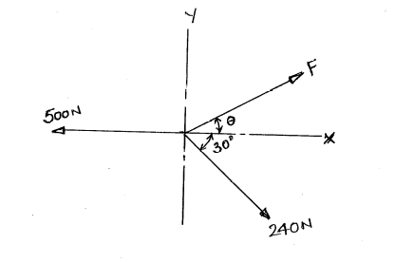 | L4 | CO1 | [7M]
2. |  | Determine the forces in all the members of the truss shown in fig. and indicate the magnitude and nature of forces on the diagram of the truss. All inclined members are at 60 to horizontal and length of each member is 2 m.  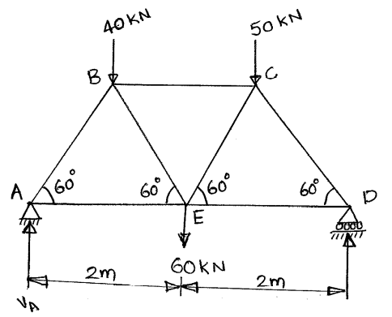 | L5 | CO2 | [15M]
3. |  | Determine the centroid of the quarter circle shown in fig. when radius is r.  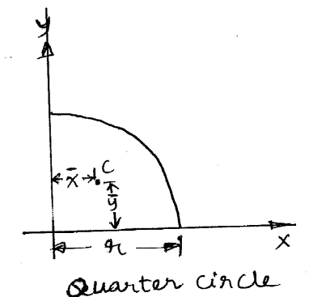 | L5 | CO3 | [15M]
4. |  | The cross section of a culvert is shown in fig. compute the moment of inertia about the horizontal X axis.  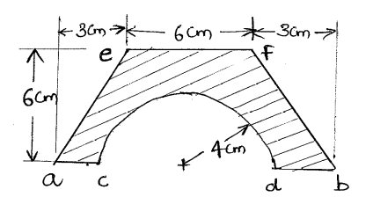 | L5 | CO4 | [15M]
5. |  | Determine acceleration of bodies in fig. if coefficient of kinetic friction is 0.2 at all contact surfaces. Body A weighs 200N and B weighs 300N.  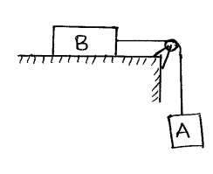 | L5 | CO5 | [15M]
6. |  | The composite pulley shown in fig. weighs 800N and has a radius of gyration of 0.6m. The 2000N and 4000N blocks are attached to the pulley by inextensible strings as shown in the figure. Using work energy principle, determine the resulting velocity when distance moved by 4000N block is 2m and hence determine the resulting acceleration.  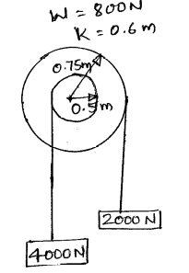 | L4 | CO6 | [15M]
7. |  | Three Cylinders are piled in a rectangular ditch as shown in fig. Neglecting friction determine the reaction between cylinder A and the vertical wall.  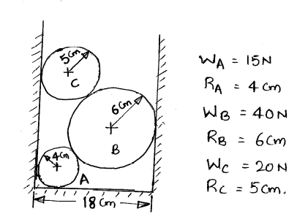 | L5 | CO1 | [15M]
8. |  | A 3000N block starting from rest as shown in Fig. slides down a 50 incline. After moving 2m it strikes a spring whose modulus is 20 N/mm. If the coefficient of friction between the block and incline is 0.2, determine the maximum deformation of the spring and maximum velocity of the block.  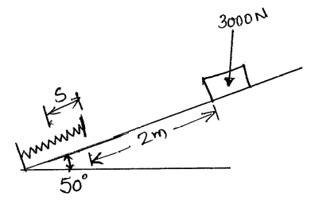 | L5 | CO4 | [15M]
-- 00 -- 00 –

